**INTRODUCTION**

**PROJECT TITLE**

**COOKBOOK YOUR VIRTUAL COOKING ASSISTANT**

**TEAM DETAILS**

|  |  |
| --- | --- |
| **TEAM LEADER** | **HABIB NISHA H** |
| **TEAM MEMBER** | **HELAN PRASANNA S** |
| **TEAM MEMBER** | **HEMAMALINI P** |
| **TEAM MEMBER** | **HEMAVATHI D** |

**PROJECT OVERVIEW**

**PURPOSE**

The purpose of a cookbook project is to collect, organize, and present recipes in a structured way so they can be easily followed and enjoyed by others. It serves as a creative documentation of food culture, cooking techniques, and personal or community experiences with food.

Goals of Cookbook Project is preparing Document traditional, family, or personal recipes for future use. Encourage experimentation and sharing of unique dishes Enhance Cooking Skills by Provide step-by-step guidance for learners and cooking enthusiasts. Spread cultural, nutritional, and cooking insights with others.

**FEATURES**

The Cookbook project includes key features such as a well-organized collection of recipes with categories, detailed ingredients, and step-by-step instructions. It provides functionalities like search and filter options to quickly find recipes, the ability to add or edit recipes, and clear details about preparation time, cooking time, and servings. Visuals such as images or icons enhance presentation, while tips, variations, and cultural or nutritional notes make the content more engaging and useful for users.

**ARCHITECTURE**

**COMPONENT STRUCTURE**

In a Cookbook project built with React, the App component serves as the root, managing global state such as the list of recipes and navigation between pages. A Layout component organizes the structure with a header, sidebar, and footer. Page components (like Home, Recipe List, and Recipe Details) display different parts of the cookbook. Container components handle tasks such as fetching recipes, filtering by category, or managing search results, while Presentational components (like Recipe Card, Ingredient List, and Step Guide) focus only on displaying the recipe details. Shared components such as buttons, modals, and input fields are reused throughout. These components interact through props, events, and context, ensuring smooth data flow from the recipe database to the user interface.

**STATE MANAGEMENT**

In the Cookbook project, state management can be handled using the Context API to avoid prop drilling and provide easy access to shared data such as the recipe list, selected recipe, and user preferences. The Context API allows the App component to act as a provider, making global state available to child components like Recipe List, Recipe Details, and Search Bar. This ensures smooth data flow, consistent updates across components, and a cleaner structure compared to passing props through multiple levels.

**ROUTING**

In the Cookbook project, routing can be managed using React Router, where the App component defines different routes for pages like Home, Recipe List, Recipe Details, and Add Recipe. Each route is mapped to a specific page component, allowing smooth navigation without reloading the page. Nested routes can be used within the layout to keep a consistent header and footer across all pages.

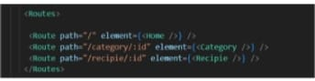

**SETUP INSTRUCTIONS**

**PRE-REQUISITES**

* Node.js and npm
* React.js
* HTML, CSS, and JavaScript
* Vs-code
* Git/Github

**INSTALLATION**

Node.js :

* Install Node.js and npm on your development machine, as they are required to run JavaScript on the server-side.

Download: https://nodejs.org/en/download/

After Downloading, the installation process begins

✅ In Windows:

1. Run the downloaded .msi installer.
2. Follow the setup wizard:

* Accept the license agreement
* Choose the destination folder
* Make sure "Add to PATH" is selected
* Keep default options unless you know otherwise

1. Finish the installation.

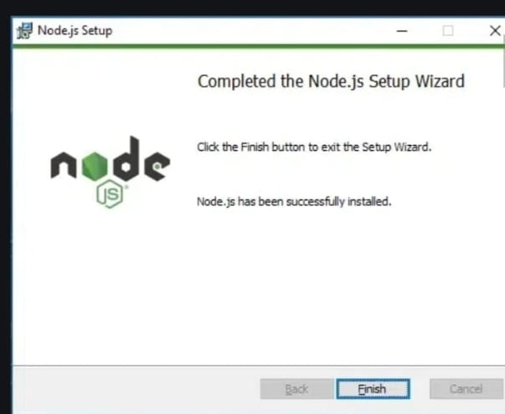

1. Verify the installation:
   * Open Command Prompt or PowerShell  Enter to check the Node.js version.
   * Type npm -v and press Enter to check the npm version.
   * Both commands should return version numbers, confirming successful installation.

React.js:

* Create a new React app:

npx create-react-app my-react-app

Replace my-react-app with your preferred project name.

* Navigate to the project directory:

cd my-react-app

* Running the React App:

With the React app created, you can now start the development server and see your React application in action.

* Start the development server:

npm start

This command launches the development server, and you can access your React app at https://localhost:3000 in your web browser.

**FOLDER STRUCTURE**

**CLIENT**

The Cookbook project React app is organized into clear folders for maintainability: the src/components folder contains reusable UI elements like buttons, recipe cards, and input fields; src/pages holds full-page views such as Home, Recipe List, and Recipe Details; src/assets stores images, icons, and styles; and src/context (or store) manages global state using Context API or Redux. Additional folders like src/services can handle API calls, while src/utils keeps helper functions. This structure ensures separation of concerns, reusability, and easy scalability of the project.

**UTILITIES**

In the Cookbook project, helper functions and utilities are used to simplify common tasks, such as formatting cooking times, converting ingredient measurements, or filtering recipes by category or keyword. Utility classes may handle validation for recipe forms or manage local storage for saving favorites. Custom React hooks, like useFetchRecipes for API calls or useRecipeSearch for handling search and filter logic, encapsulate reusable logic and keep components clean. These helpers and hooks improve code readability, reduce repetition, and make the application more efficient and maintainable.

**RUNNING THE APPLICATION**

* Open the VS-code and you can see the code file in it.
* You have to install node modules for project execution, So use this command

npm install

* After installing all the node modules enter the project run command

npm start

* Now your application will be opened in browser with url

https://localhost:3000

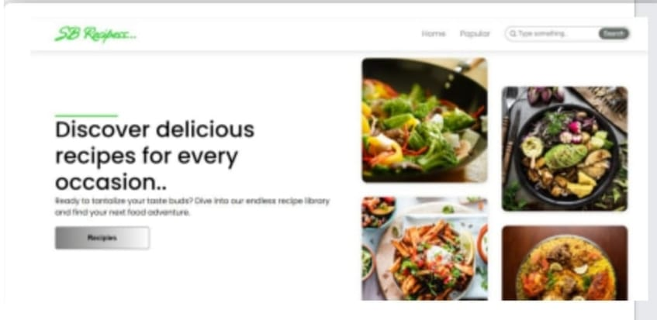

**COMMENT DOCUMENTATION**

**KEY COMPONENTS**

The Cookbook project is structured with several major components, each serving a clear purpose. Core components like RecipeCard display individual recipe details, receiving props such as title, image, ingredients, and instructions. The RecipeList component organizes and renders multiple RecipeCards, typically receiving an array of recipe objects as props. Navigation-related components like Navbar and Footer provide layout consistency, handling props for links or branding details. Additionally, form components such as AddRecipeForm manage user inputs for creating or editing recipes, receiving props for submission handlers and initial data. Together, these components ensure modularity, reusability, and a clean flow of data through props.

**REUSABLE COMPONENTS**

The Cookbook project includes several reusable components that make the UI consistent and efficient, such as a Button component configurable by size, color, and variant (primary, secondary), a RecipeCard component that displays recipe images, titles, and quick details, and an InputField component with props for label, placeholder, and validation. Other shared components like Modal (for adding or editing recipes) and Navbar (for navigation) are also reusable across pages. Each component is designed to accept props for customization, ensuring flexibility while maintaining a clean and uniform design throughout the project.

**STATE MANAGEMENT**

**GLOBAL STATE**

In the Cookbook project, global state management is handled using the Context API, which allows shared data like the recipe list, selected recipe, search filters, and user preferences to be accessed across components without prop drilling. The App component wraps the application with a Context Provider, making state available to child components such as RecipeList, RecipeDetails, and SearchBar. When a user searches, adds, or updates a recipe, the state is updated in the provider, and changes flow down to all subscribed components, ensuring the UI stays synchronized across the application.

**LOCAL STATE**

In the Cookbook project, local state is managed within individual components using React’s useState hook to handle UI-specific data and interactions. For example, a SearchBar component may track the current search input, a RecipeForm may manage field values and validation errors, and a Modal may store its open/close state. These local states are isolated to their respective components, ensuring they remain lightweight and responsive, while only essential data that needs to be shared across the app is lifted to the global state using Context API.

**USER INTERFACE**



**STYLING**

**CSS FRAMEWORKS**

In the Cookbook project, styling is managed using Tailwind CSS, which provides utility-first classes for building responsive and modern UI components quickly. Tailwind ensures a consistent design system while reducing the need to write custom CSS from scratch. Additionally, custom styles can be added in a dedicated stylesheet for unique branding elements, and component-level styling can be enhanced with libraries like Styled-Components if needed. This combination allows for flexibility, scalability, and clean maintainable code throughout the project.

**THEMING**

In the Cookbook project, a simple custom design system is implemented to maintain consistency across the application. This includes a defined color palette (for backgrounds, text, and accent highlights), reusable typography styles, and standardized spacing rules. With Tailwind CSS (or a similar utility framework), these styles are applied globally, making it easy to enforce a cohesive look and feel. Theming can also be extended to support light and dark modes, ensuring better accessibility and personalization for users while keeping the UI visually appealing and uniform across all components.

**TESTING**

**TESTING STRATERGY**

For the Cookbook project, testing is approached in three layers to ensure reliability. Unit testing with Jest verifies that individual components like recipe cards or forms work correctly in isolation. Integration testing using React Testing Library checks that multiple components interact as expected, such as adding a recipe updating the recipe list. Finally, end-to-end testing with tools like Cypress simulates real user workflows, ensuring the full application—from searching recipes to navigating pages—functions smoothly.

**CODE COVERAGE**

For the Cookbook project, ensuring adequate test coverage involves using tools and techniques that track which parts of the code are tested. Jest provides built-in coverage reports that show which lines, functions, and branches are tested, helping identify untested areas. React Testing Library encourages testing from the user’s perspective, ensuring key interactions and UI behaviors are covered. Additionally, techniques like writing test cases for edge scenarios, combining unit and integration tests, and using mock data for API calls help ensure that both common and rare use cases are properly tested, improving overall application reliability.

**KNOWN ISSUES**

* May return incomplete results for recipes with special characters.
* Sometimes allows empty fields if users bypass input checks.
* Large image files may fail to upload properly.
* Certain screens appear misaligned on smaller devices.
* In some cases, refreshing a page may reset unsaved recipe data.

**FUTURE ENHANCEMENTS**

We are include adding new components like user profile pages, recipe rating systems, and personalized recommendation sections. Animations can enhance user experience, such as smooth transitions between pages, hover effects on recipe cards, and interactive loading indicators. Enhanced styling could involve implementing a dark mode, responsive design optimizations for all devices, and a more consistent visual theme with custom fonts, colors, and icons. Additional features like advanced search filters, social sharing options, and offline recipe access could further improve usability and engagement.

**CONCLUSION**

The Cookbook project successfully demonstrates how a modern web application can simplify recipe management through a clean interface, interactive features, and responsive design. By integrating key functionalities such as recipe search, creation, and categorization, the project enhances usability and user engagement. While some minor bugs and layout issues exist, the structured testing approach ensures reliability and provides a foundation for continuous improvement. With potential future enhancements like advanced filtering, user profiles, and animations, the Cookbook project has strong potential to evolve into a more feature-rich and user-friendly application.